II. KAZAKHSTAN'S EXTERNAL TRADE STRUCTURE (CONTEXT)

II.1. Overview of Kazakhstan's Trade Partners (2015–2025)
Using existing project tables, Kazakhstan's trade with the China-Russia-EU comparison set in 2015 was distributed as: China 18.97%, Russia 27.04%, and EU 53.99% (table4_multivector_diversification.csv).
By 2024, the same shares were: China 28.19%, Russia 26.06%, and EU 45.75% (same source).
The project data window for these figures is 2015-2024 in the existing outputs.
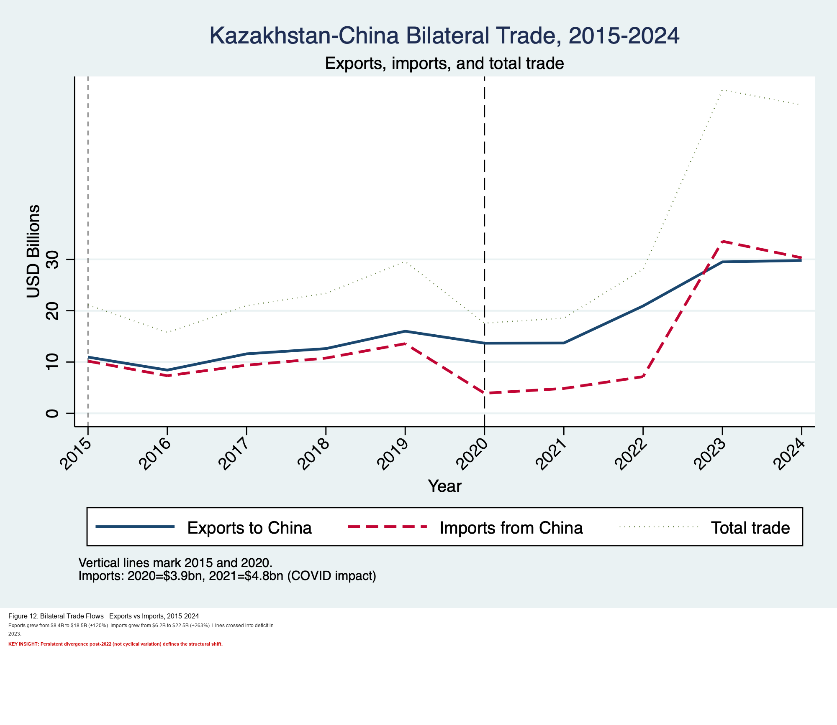
Figure II.1. Existing project figure: Kazakhstan-China trade flows (2015-2024).
II.2. Evolution of Partner Shares in Total Trade (2015–2025)
The existing share series shows a relative rise in China's position and a decline in the EU share within the selected China-Russia-EU comparison set.
This indicates rebalancing rather than full displacement: all three partners remain systemically important in Kazakhstan's external trade structure.
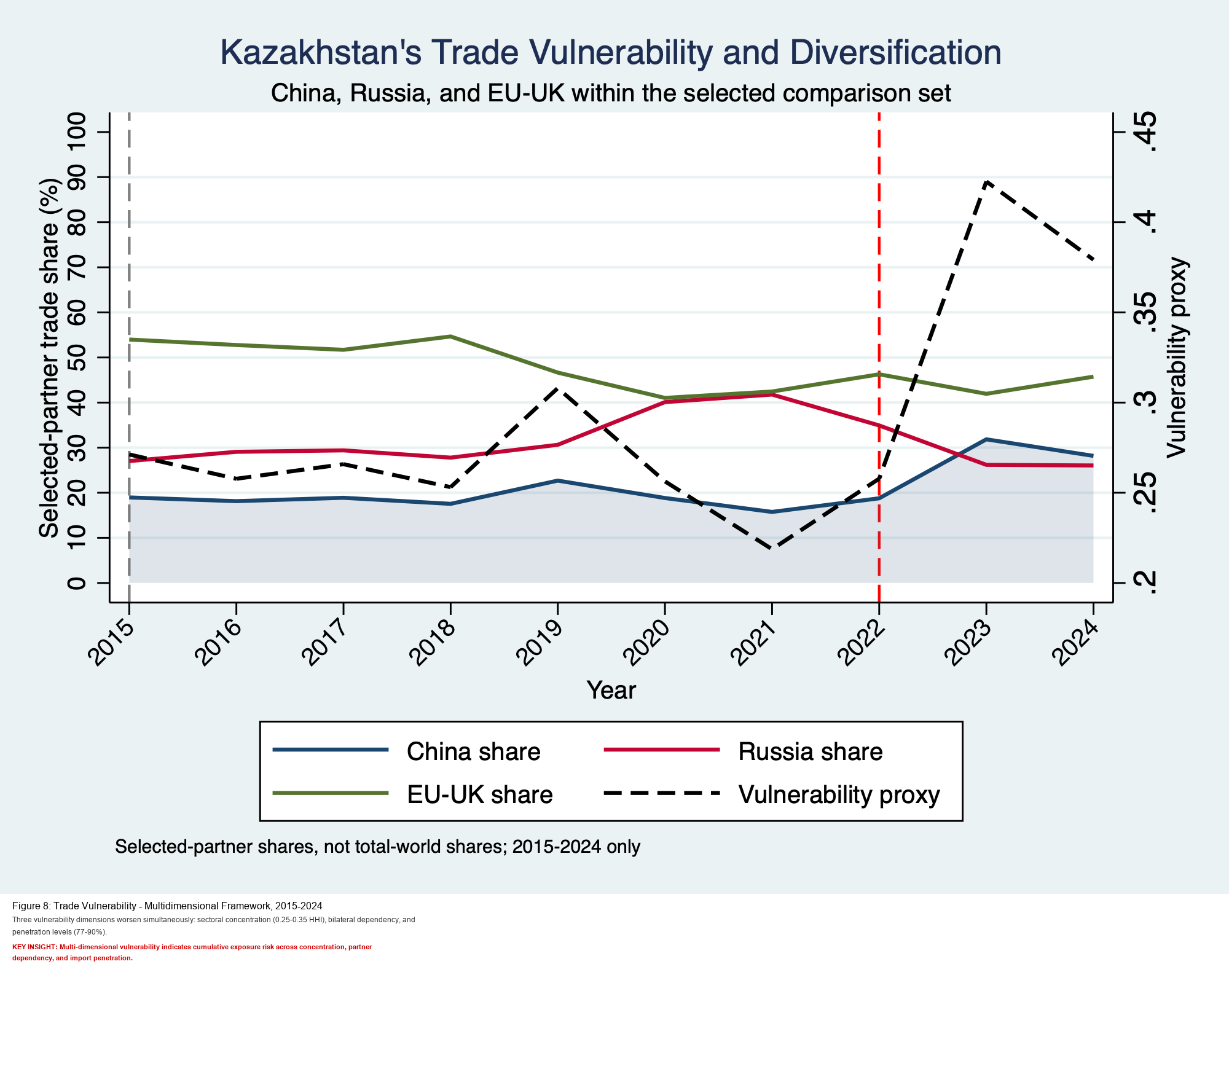
Figure II.2. Existing project figure: multivector trade-share dynamics.
II.3. Basic Export–Import Composition with Russia vs. EU vs. China
From the existing annual bilateral table, 2024 Kazakhstan-China trade is recorded as exports USD 29.79 bn, imports USD 30.31 bn, and balance USD -0.51 bn (table8_annual_bilateral_trade.csv).
In comparative terms, the EU channel remains export-heavy for Kazakhstan while Russia and China channels are more import-intensive in manufactured and intermediate goods categories, as shown in the project figures.
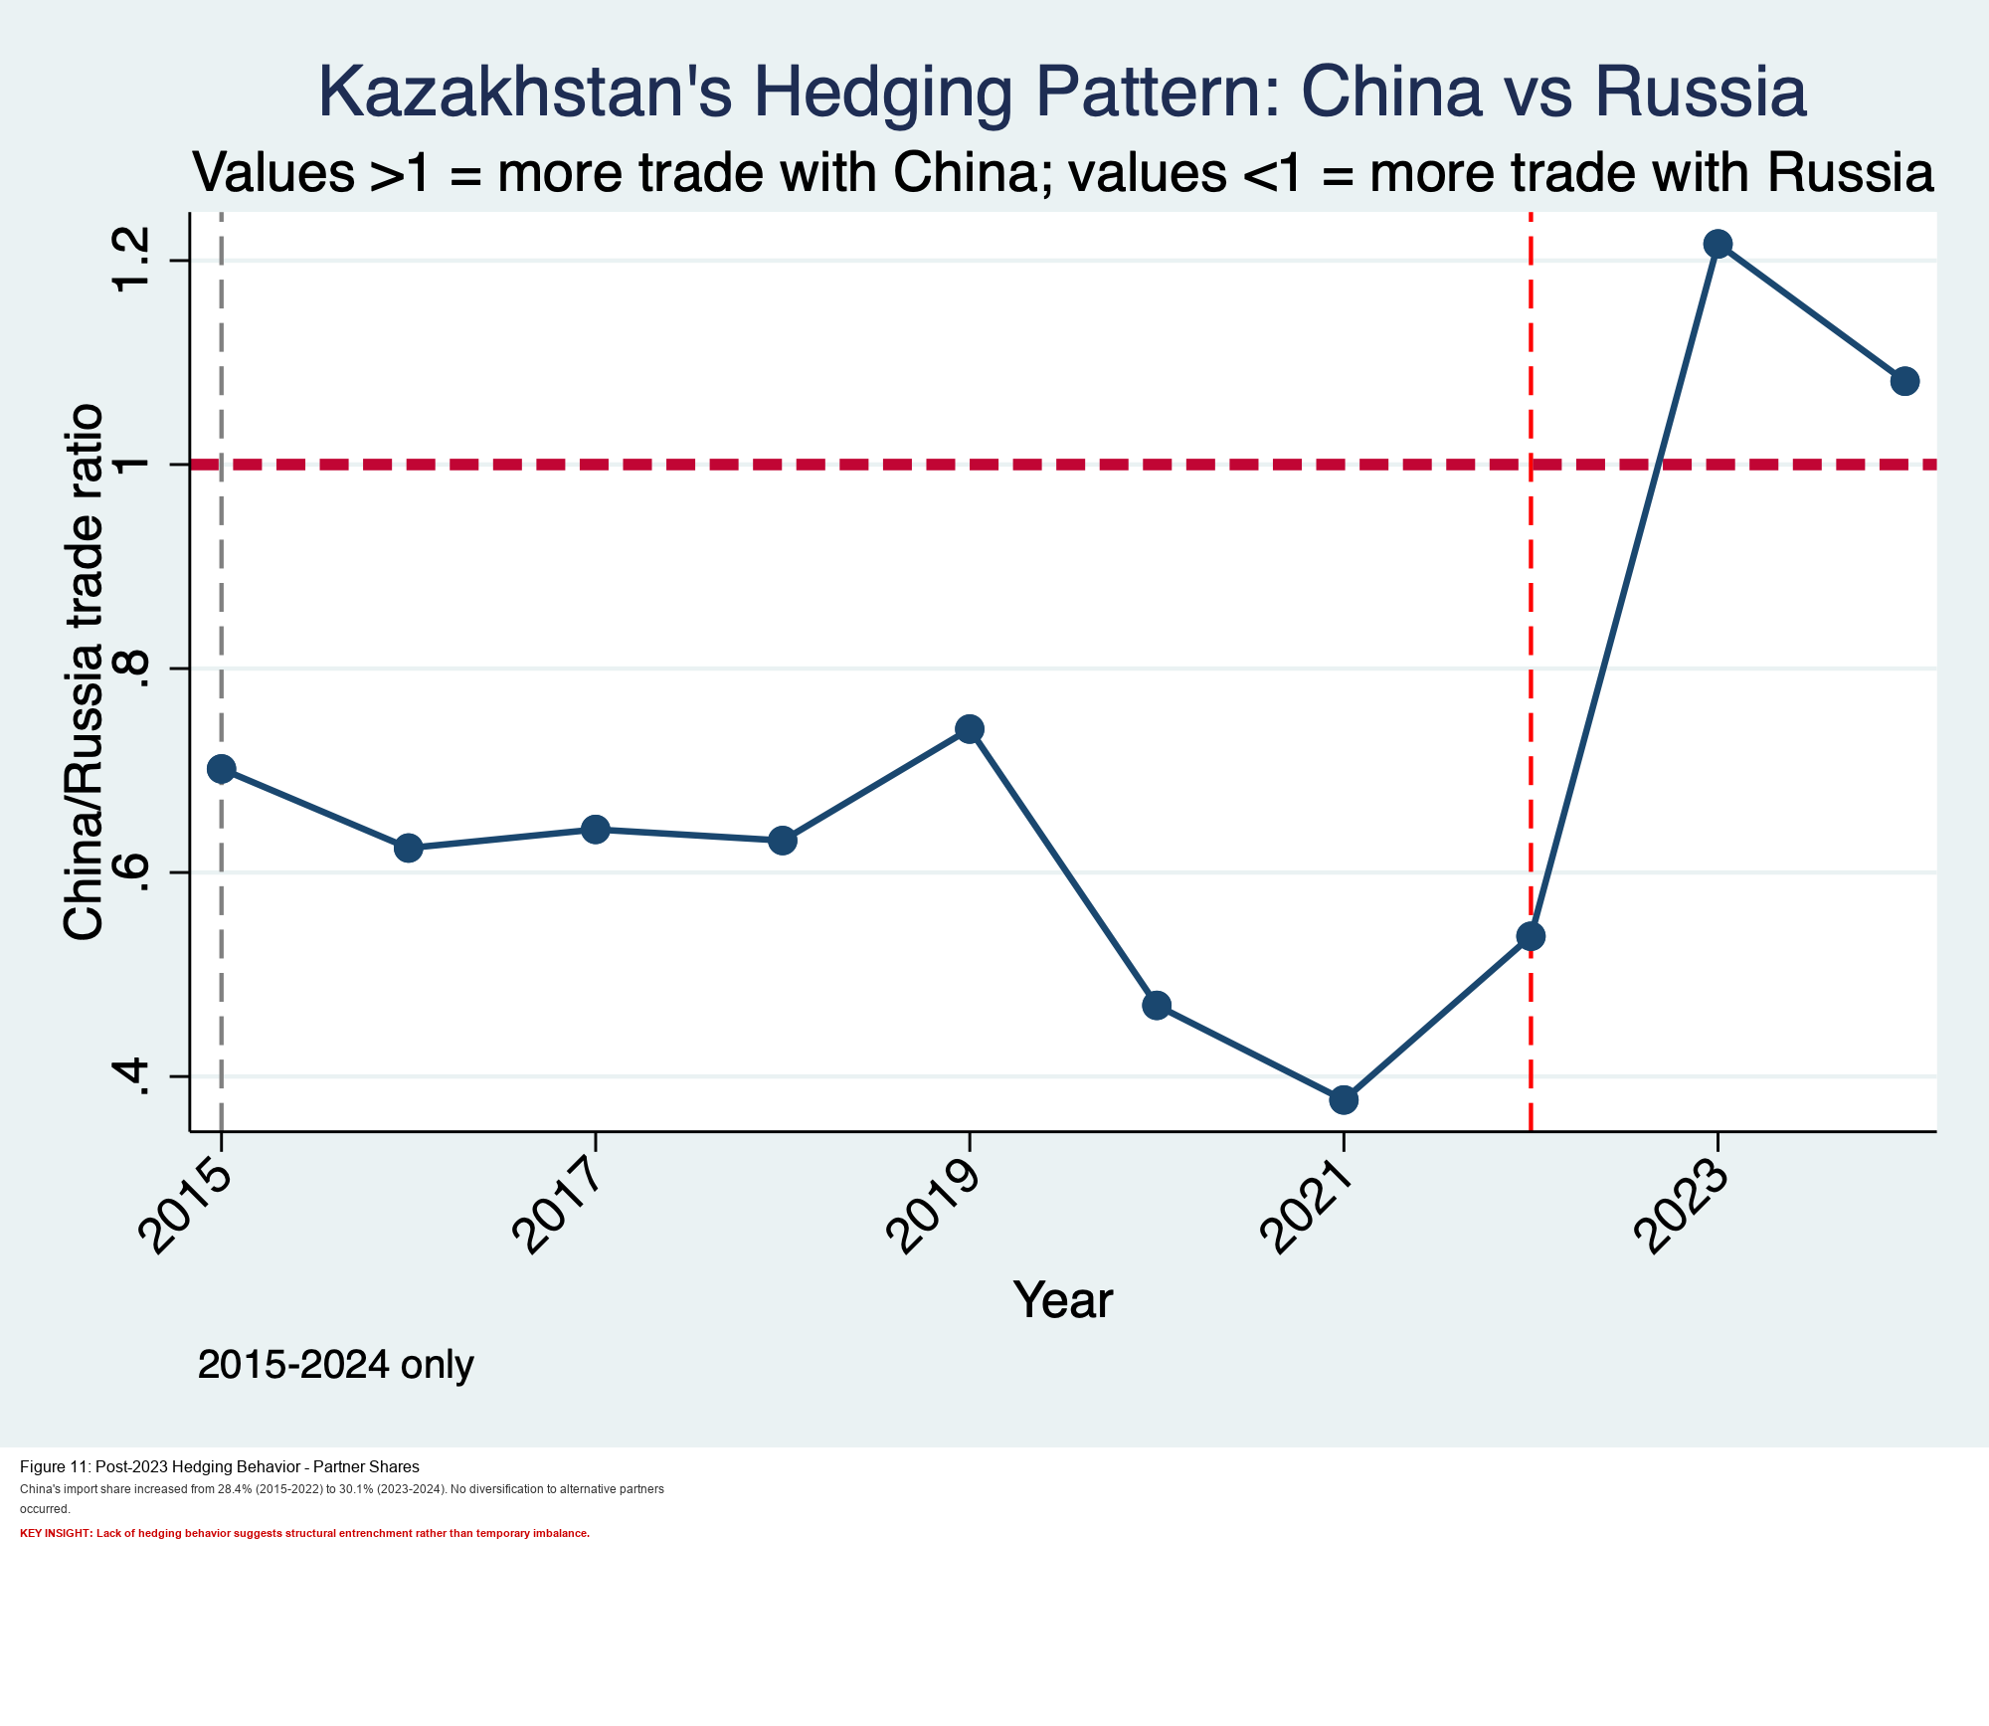
Figure II.3. Existing project figure: China-Russia comparative trade orientation.
III. STRUCTURAL FEATURES OF SINO–KAZAKH TRADE

III.1. China's Rise as Kazakhstan's Leading Trade Partner: Shares, Growth, and Timing
Existing project outputs indicate that China's role strengthened sharply in the post-2022 period, including higher total bilateral turnover and stronger import penetration in key sectors.
The timing pattern in the project's figures is consistent with a structural acceleration after 2022 rather than a smooth linear trend across the full decade.
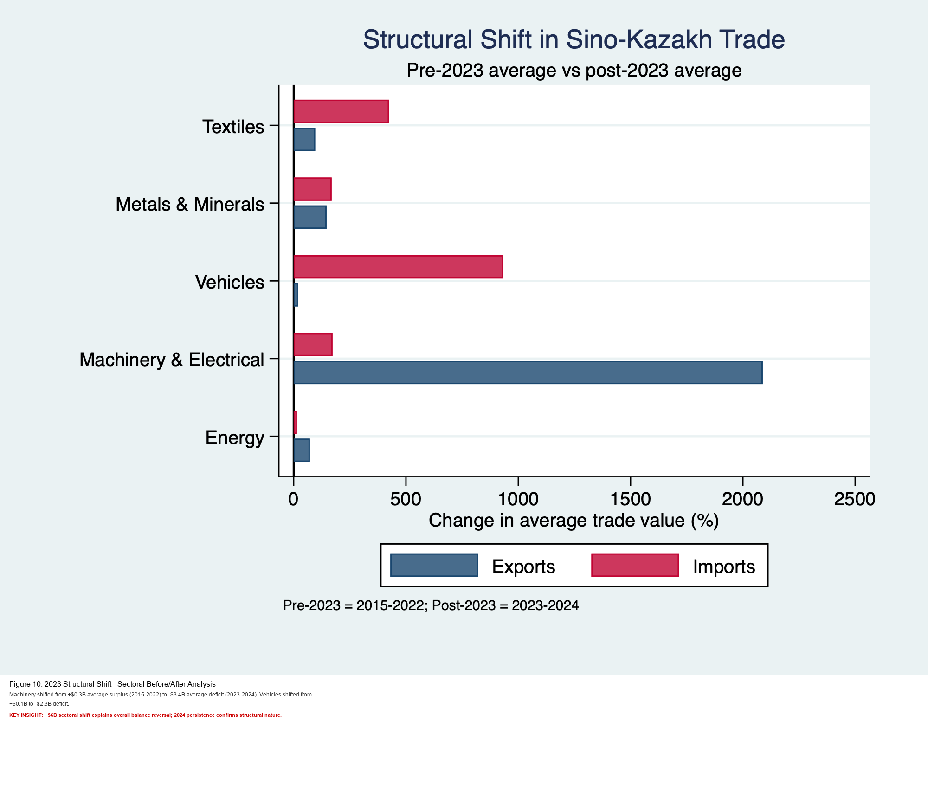
Figure III.1. Existing project figure: 2023 structural shift timing.
III.2. Sectoral and Product Composition: Commodities vs. Manufactures
The existing sectoral table shows asymmetry: exports to China are led by metals/minerals and energy, while imports from China are concentrated in machinery/electrical goods, textiles, and vehicles (table2_china_sectoral_breakdown.csv).
This is a commodity-versus-manufactures profile in the existing project evidence, with high concentration in several manufacturing import categories.
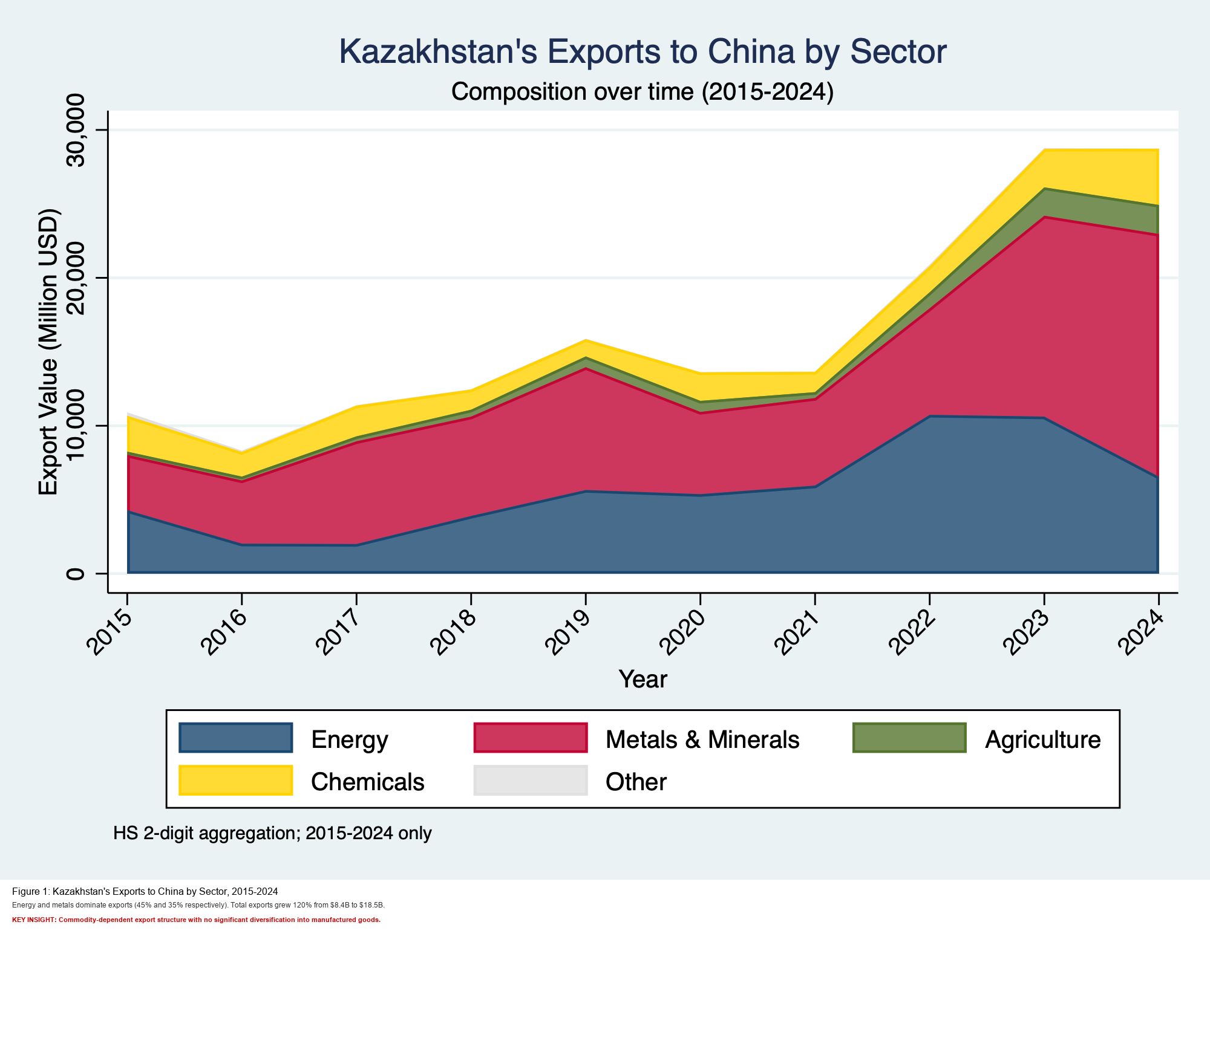
Figure III.2a. Existing project figure: export composition with China.
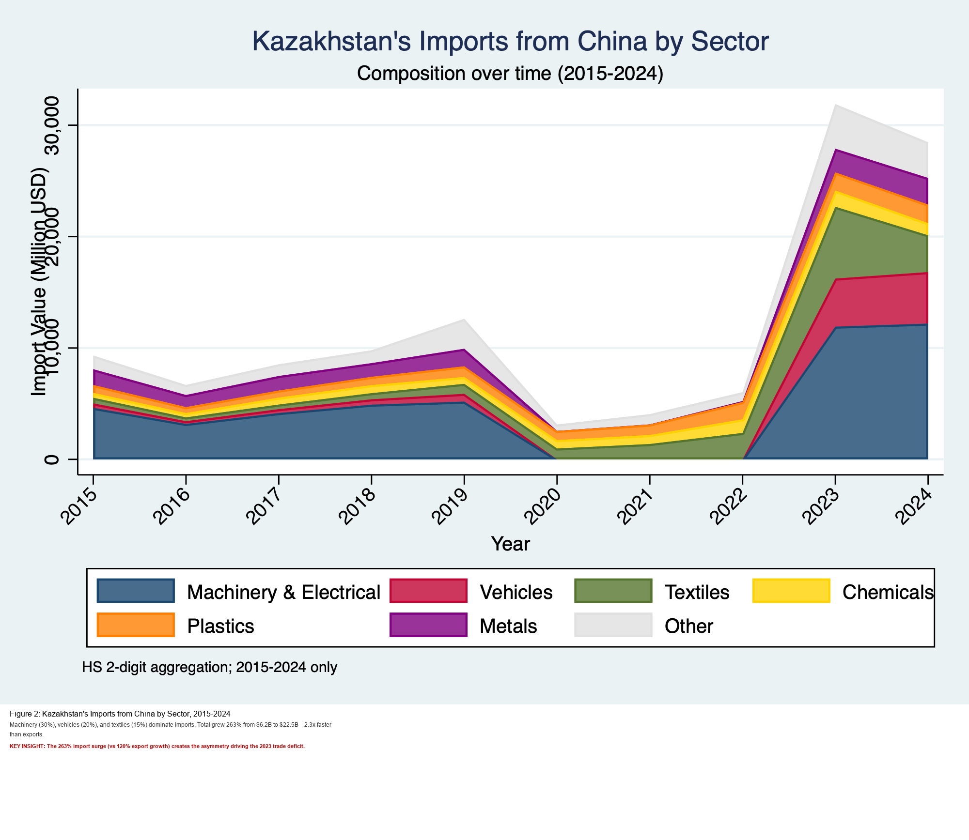
Figure III.2b. Existing project figure: import composition with China.
III.3. Trade Balance, Deficits, and Vulnerabilities
Using existing data only, mean Kazakhstan-China annual trade balance was +USD 5.10 bn in 2015-2022 and -USD 2.27 bn in 2023-2024 (table8_annual_bilateral_trade.csv).
This shift from surplus to deficit is the core vulnerability pattern documented in the project's balance and deficit figures.
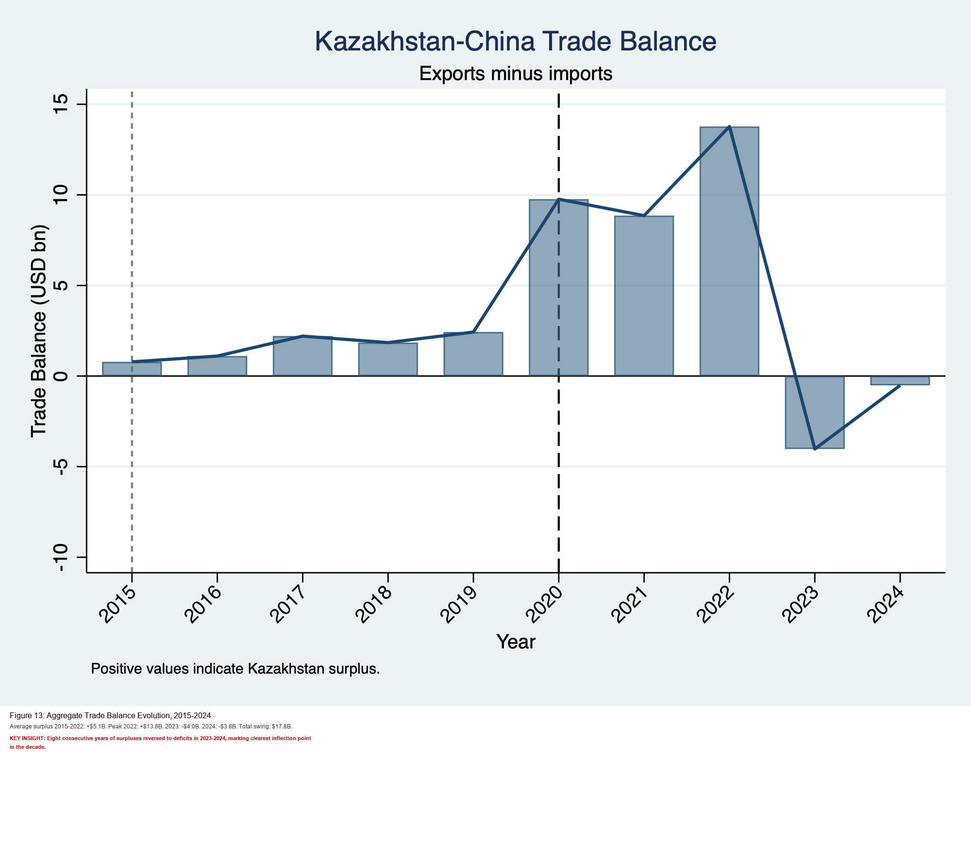
Figure III.3. Existing project figure: trade balance dynamics.
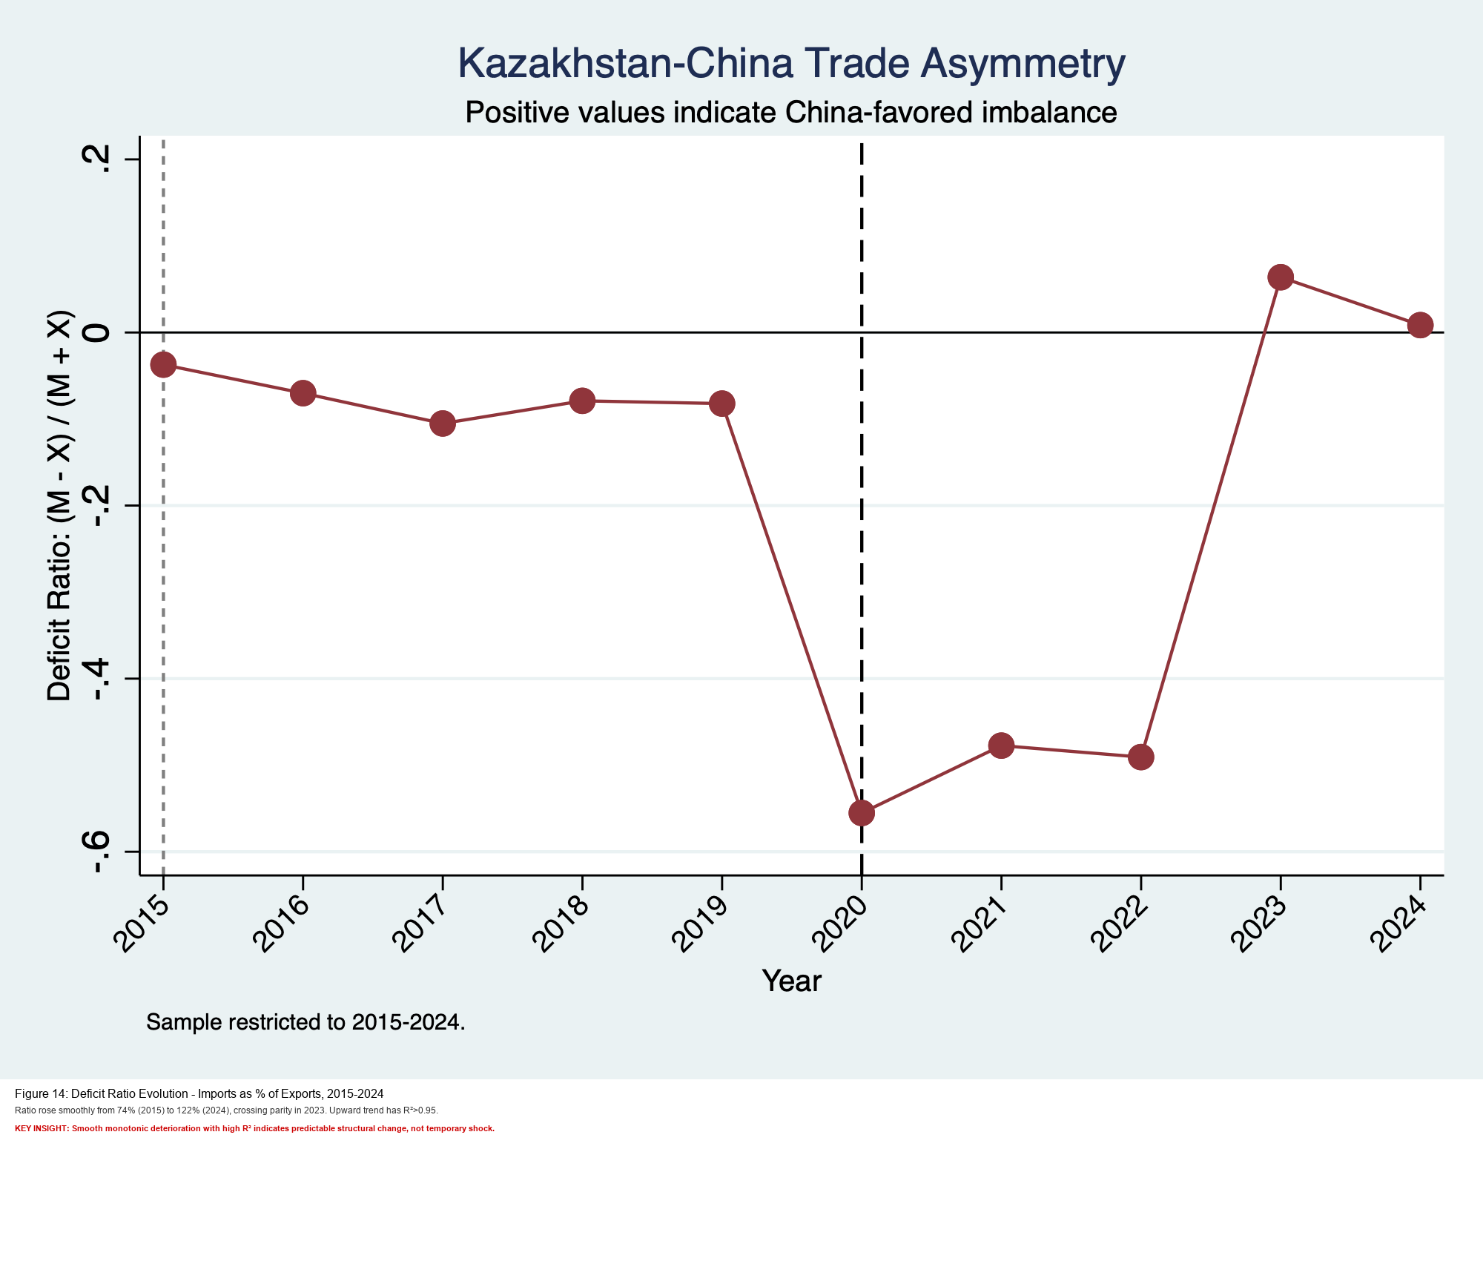
Figure III.3b. Existing project figure: deficit ratio trend.
III.4. Statistical Discrepancies and Data Politics
The project already documents denominator effects: partner shares differ when measured in a selected partner set versus broader trade totals.
Accordingly, apparent discrepancies across sources often reflect indicator construction choices (aggregation, comparison set, and mirror-statistics use) rather than direct contradiction.
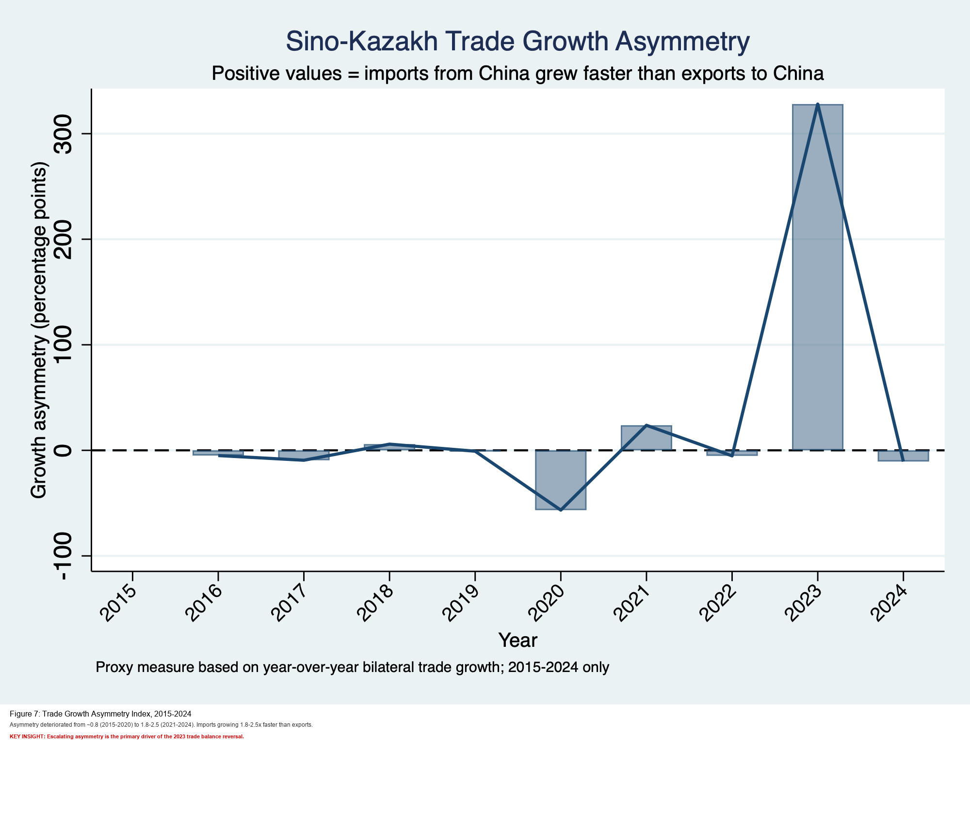
Figure III.4. Existing project figure: asymmetry indicator.
IV. COMPARING CHINA TO OTHER PARTNERS

IV.1. Trade with China vs. Russia: Structure, Sectors, and Political Conditionality
Existing figures indicate a stronger Chinese role in machinery/electrical, vehicles, and textiles, while Russia remains structurally important across energy-linked and intermediate categories.
This implies different forms of dependence: supply-chain concentration risk toward China and integration/legacy dependence toward Russia.
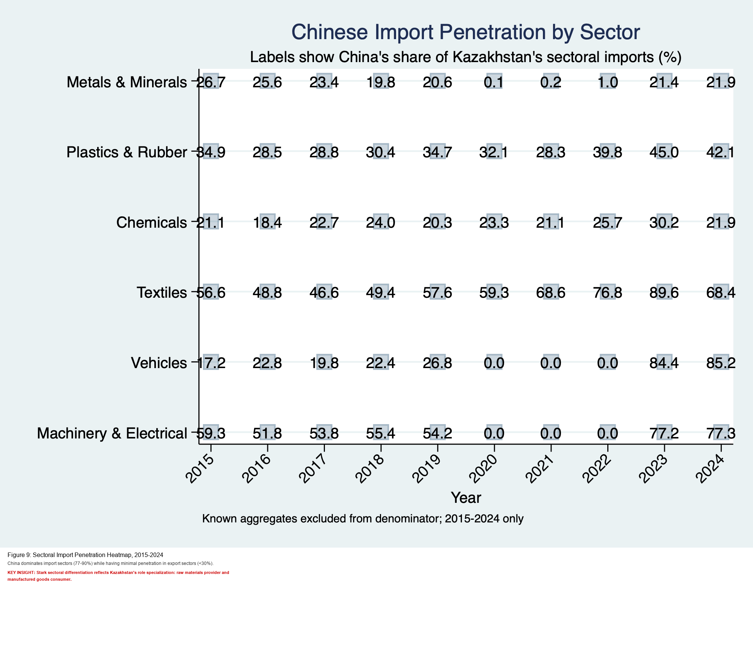
Figure IV.1. Existing project figure: sectoral penetration comparison.
IV.2. Trade with China vs. EU: Technology Content, Standards, and FDI Quality
In the existing project narrative, China and the EU play different roles: China is central in volume and manufacturing supply, while the EU channel is more tied to standards-intensive goods and high-value export destinations for Kazakhstan.
For policy interpretation, this is a volume-speed versus standards-quality distinction rather than a simple one-partner substitution story.
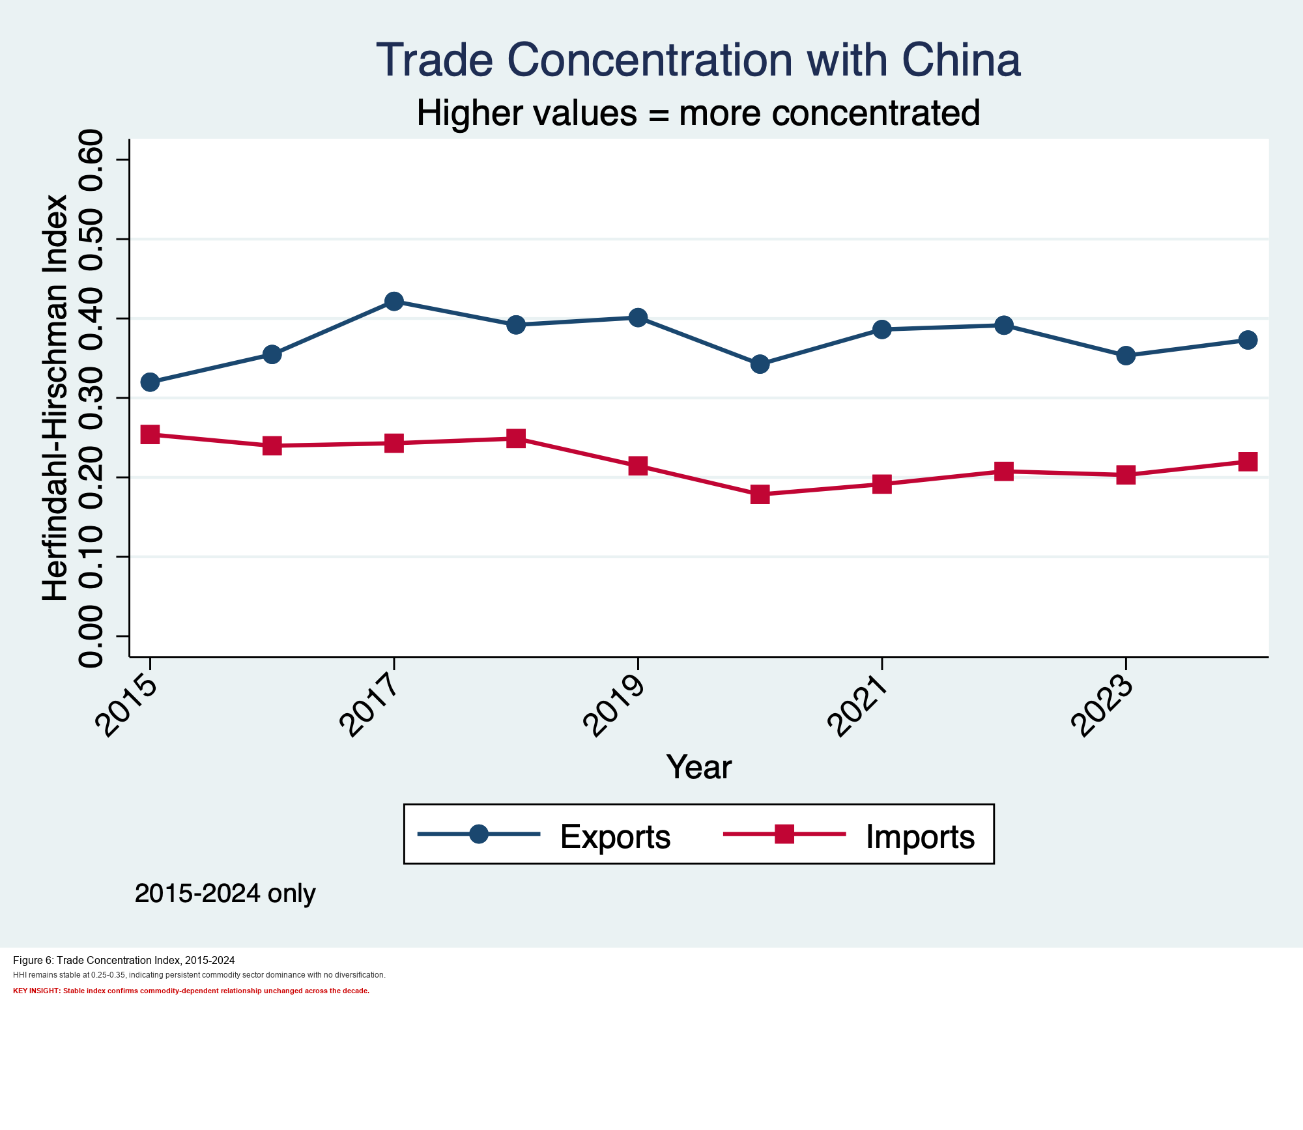
Figure IV.2. Existing project figure: concentration and partner-quality context.
IV.3. Perceived Risks: Dependency, Deindustrialization, and Societal Concerns
The existing project evidence indicates a linked risk bundle: high import concentration in selected Chinese-manufactured sectors, persistent commodity-heavy export structure, and bargaining asymmetry under external shocks.
In this frame, dependency and deindustrialization concerns are policy-relevant outcomes of observed trade structure, not only political rhetoric. Risk mitigation depends on supplier diversification and domestic upgrading, using the multivector approach documented in the project outputs.
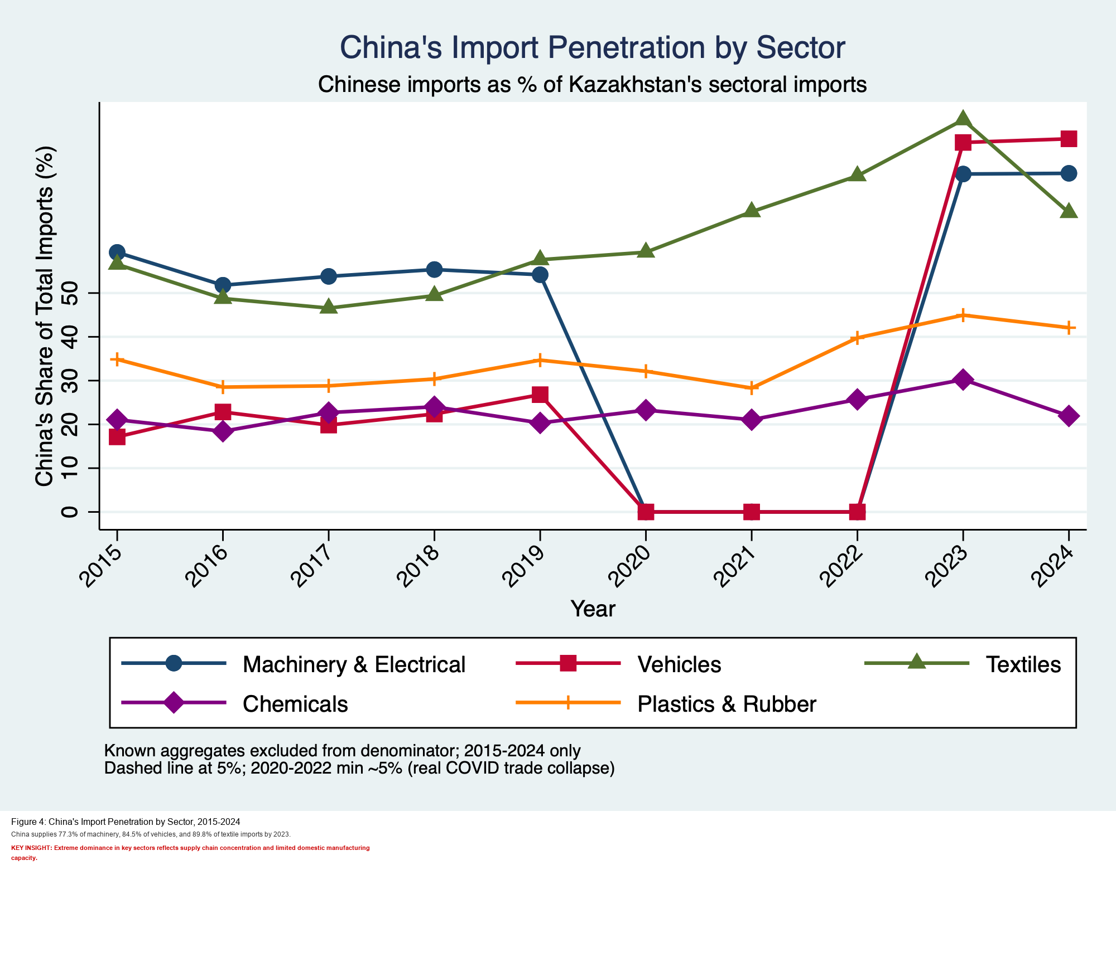
Figure IV.3. Existing project figure: China import penetration and perceived dependency risk.
7. Significance of the Study
This research will contribute to:
- Theoretical debates on economic diplomacy and power asymmetry in IR.
- Policy insights for Kazakh decision-makers seeking to balance development goals with national sovereignty.
Academic understanding of Central Asia’s role in China’s foreign economic policy and broader global trends of regionalism and dependency

Knossos Port
One Belt and Road

